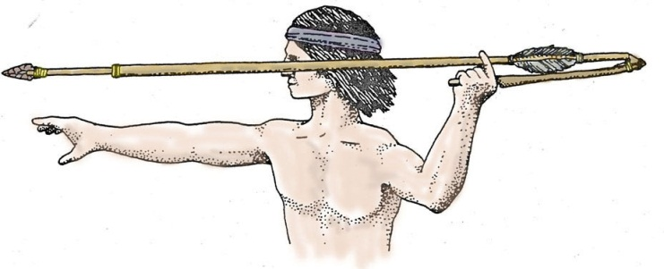

French colonization

Spanish colonization

English colonization

Hernando de Soto

The 3 G’s (God, gold, glory)

Spanish “Mission Period”

Diseases & raids

Religious freedom

New beginnings

Paleo

Archaic

Woodlands

Missisippian

Jean Ribault

Hugenots

John Rolfe & Jamestown

Rice, tobacco & indigo

**Vocabulary**

•Paleo •Shale

•Archaic •Tribe

•Woodland •Clan

• Mississippian •Shale

•Archaeologist •Sherds

• Artifacts • Nomads

• Anthropologist •Effigy

### • Culture •Atlatl

• Antiquities •Chiefdom

### •Horticulture •Beringia

•Clovis Points •Middens

•Mounds •Moat

•Palisade •Podium

•Wooly Mammoth •Mastodon

•Barter Economy • Pottery

•Maize •  Oral tradition

•Bow and arrow •Wattle and daub

### •Projectile Points •Mound builders

### (Arrow heads) •New World

### •Colonization •xpeditions

### •Spanish missions •Guale-Sea Island

### •Barrier islands •Fur trade

### • Influence •Conquistador

### •Smallpox •Monarchy

•Catholicism •Protestant

•New World •mercantilism

•Prehistoric

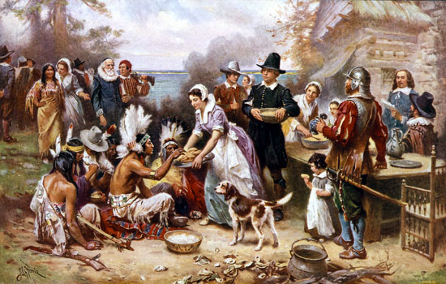

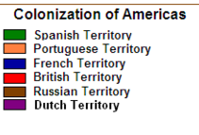

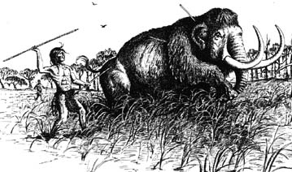

1. **How did the Native American cultures develop prior to European contact?**
2. **What impact did the environment have on the development of prehistoric Native Americans in Georgia?**
3. **What impact did the arrival of the Europeans have on the early Native American cultures?**
4. **Why did the Europeans (primarily the Spanish, French and English) explore and later settle parts of North America?**

**SS8H1, SS8E1**

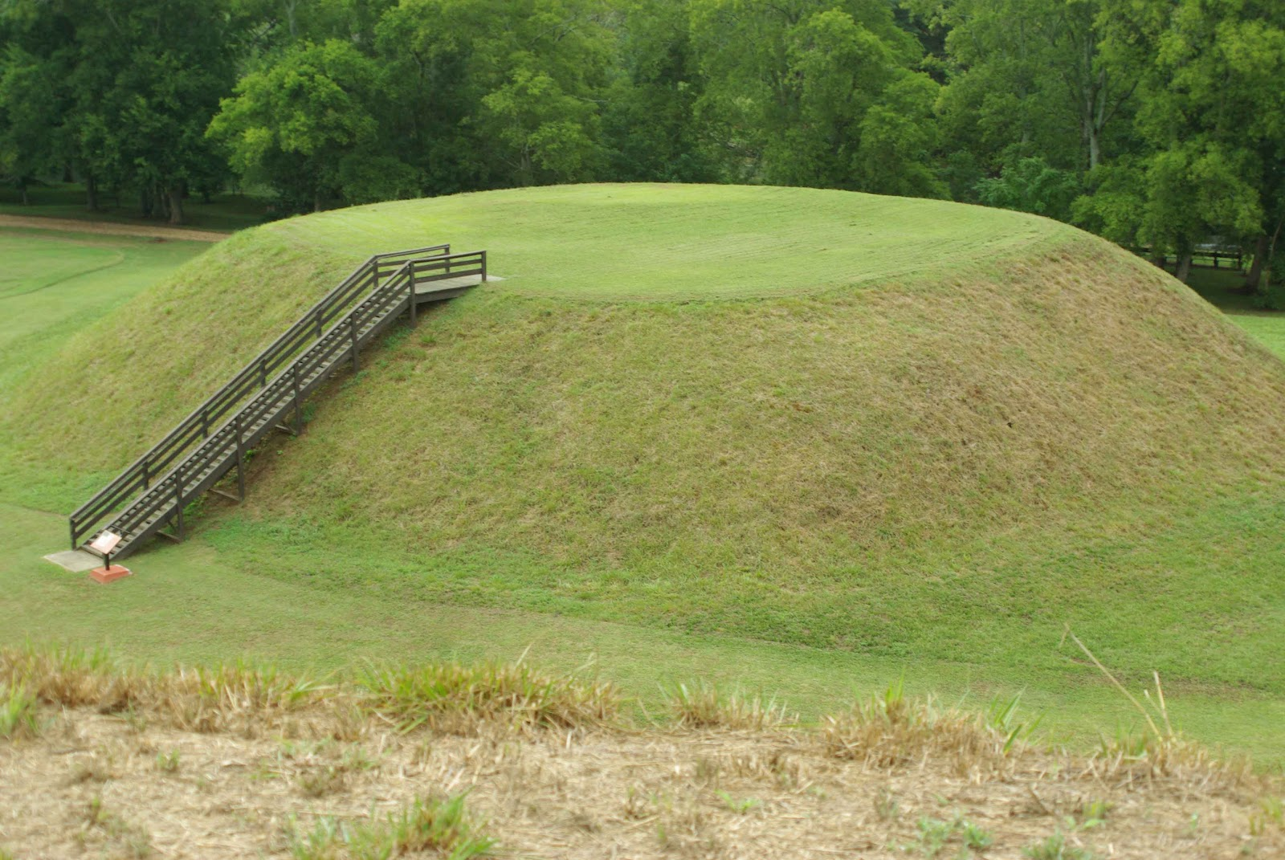

**By 1750s**

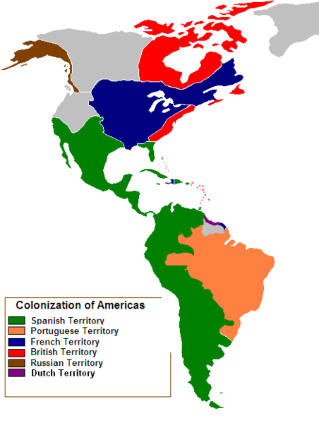



|  |  |
| --- | --- |
| **Paleo** | **12,000 - 8,000 BC** |
| **Archaic** | **8,000 - 1,000 BC** |
| **Woodland** | **1,000 BC - 1,000 AD** |
| **Mississippian** | **1000 – 1600 AD** |